Department of Statistics

The Wharton School

University of Pennsylvania

Statistics 603 August 2011
Assignment 2 Solutions

1. True or False?
a) If the standard deviation of the random variable X is 2, then the standard deviation of the random variable Y = 100X is 200
True; SD(aX) = |a| SD(X) from pg 5-10 of Module 5.
b) If X ~ N(2,2²), then 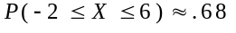
False, -2 and 6 are 2 st dev away from the mean of X (2), and we know that for a Normal distribution, the probability of being within 2 st dev is approximately .95, not .68
c) If and are independent, then
True; if two random variables are independent, Var(aX + bY) = a²Var(X) + b²Var(Y). Substitute a = 1 and b = -1 into this expression to obtain Var(X – Y) = (1)²Var(X) + (-1)²Var(Y) = Var(X) + Var(Y).
d) If 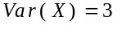, 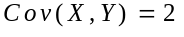 and 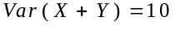, then 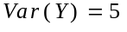
False; in general, Var(X + Y) = Var(X) + Var(Y) + 2Cov(X, Y). Plugging in the known values and solving, we find that 10 = 3 + Var(Y) + 2(2) = 7 + Var(Y). This means that Var(Y) = 3, not 5 as the problem claims.
e) If X and Y are independent random variables, then P(Y|X) = P(X|Y).
False. Independence implies that the conditional probabilities are equal to the marginal probabilities, P(Y|X) = P(Y) and P(X|Y) = P(X). Independence does not imply that the marginal probabilities agree.
f) Large values of the chi-squared statistic indicate association in a contingency table.
True. See Module 4, page 6.
2. Option Pricing: The data set gold.xls, which you studied in assignment 1, contains end-of-month values for the price of gold in London for February 1980 through December 1997. .
- Consider first the following general options pricing problem. Suppose A stands for a future event that will occur with probability p, and consider an option that pays W dollars if A occurs. Find a formula for the fair price of such an option. Your answer should be in terms of W and p.
Let Y the payoff of the option. Thus, Y is a random variable which pays W with probability p and 0 with probability (1-p). The fair price is E[Y] = pW + (1-p)0 = pW.

- Now consider the problem of pricing an option which pays one million dollars if the price of gold declines by at least 10 percent during the next month Note that to use your formula from a, you will need to approximate
p = P(gold declines by 10 percent during the next month).
Assuming that the sequence of pct monthly price changes in gold.xls are independent random draws from a Normal distribution, approximate p and use this to price the option.
From the JMP summary statistics,

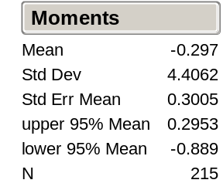

we have a mean of -.297 and a standard deviation of 4.406. Assuming that the pctchange for gold in the next month is a random draw from N (-.297, 4.406²), we can use JMP (see the file Gold Option Prob 2b.jmp) to estimate

p = P(gold declines by at least 10% during next month) = .0138

Using our previously obtained formula, the fair price is then
pW = (.0138)(1,000,000) = 13,800.

- In January 1980 the price of gold increased by 45.834 percent. Use this additional data point to price the option (still assuming the Normal model). What is your reaction to the new price?
(Add the point with Rows > Add Rows, fill in 1 and check “At start”; enter 45.834 in the first field of .) The mean and standard deviation are given by:
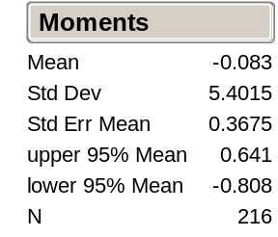
Using the mean –0.083 and standard deviation 5.4015, the probability of a drop greater than 10 percent is 0.0332 (see “Gold Option Prob 2c.jmp”), so the price of the option would be 1,000,000*0.0332=33,200. Note that the price more than doubles simply from the addition of that single point. It is probably a bad idea to price an option using a model that is so heavily influenced by a single point, regardless of whether you feel the point is an outlier or not.
(You may wonder why the price of the option increased, in spite of the fact that the additional point raises the mean from –.297 to –0.083. Shouldn’t the probability of observing pctchange < -10.0 be smaller since the mean shifted up? The answer is that the standard deviation also changed, from 4.4 to 5.4. In this case, raising the spread of the normal distribution by 1.0 overpowers the effect of raising the mean by 0.21.)
- The price that you found for the option was very much based on the Normal model which as you saw in Assignment 1 is not a believable model for this data. If you were unwilling to assume any model for the population of pct changes, a simple approach would be to approximate p by the proportion of months for which the price of gold declined by at least 10%. Price the option using this value of p and compare this answer to your previous answer. Which price do you find more appealing? Explain.
You will get one of two possible values of p, depending on whether you choose to include January 1980. If you didn’t, then p = 6/215 = .027907; if you did, then p = 6/215 = .027778. So your price for the option will be either $27,907 or $27,778. Either way, we observe that the price is higher than the price for the option using a Normal model and excluding Jan 1980, and the price is lower than the price for the option using a Normal model and including Jan 1980. In view of the apparent non-Normality of the percentage changes, we might prefer estimating the probability p by relative frequencies, without the Normal model. Hence the option price would be in the order of $27,900.

3. Portfolio Construction: Here are summary statistics on monthly returns for four U.S. common stocks, based on 60 observations from January 1991 through December 1995.

Company | Merck | USAirways
Mean | 0.0088 | 0.0097
Std. dev. | 0.0497 | 0.1597
The correlation between Merck and US Airways was 0.211.

Note: All the calculations below for this problem can be carried out conveniently in Excel. See the file Portfolio Prob 3abc.xls. In particular, the optimization in part c can instead be carried out using the Solver function in Excel.

a) Let P be a portfolio with half the money invested in Merck and half invested in USAir. Will P be riskier than a portfolio with all the money invested in Merck?
First note that the variance of a portfolio with all the money invested in M would be just the variance of the stock M, i.e., (.0497)² = .00247).
Next, the variance of the portfolio P is given by the following formula:
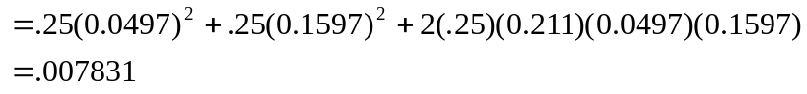

Recall that Cov(M,U) is obtained from Corr(M,U) by
Cov(M,U) = Corr(M,U)*sd(M)*sd(U)
We see that the variance of P is greater than the variance of M (we probably should have expected this result), hence P is riskier than a portfolio with all money invested in M.
- Find the approximate long run expected return for each two stocks.
We use the formula E(X) – Var(X)/2 to calculate the approximate long run expected return.
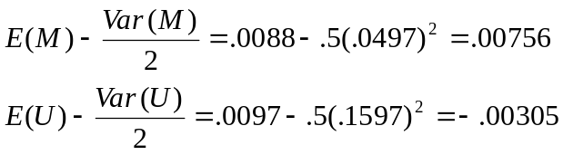

So, M has a long run expected return of approximately .0076, and U has a long run expected return of approximately -.0031.
- Construct a portfolio of the form wMerck + (1- w)USAirways, and find the fraction w that maximizes the approximate long run expected return.
For this problem, we need an expression for the long-run expected return in terms of w. We use the formula E(X) – Var(X)/2 for this part:

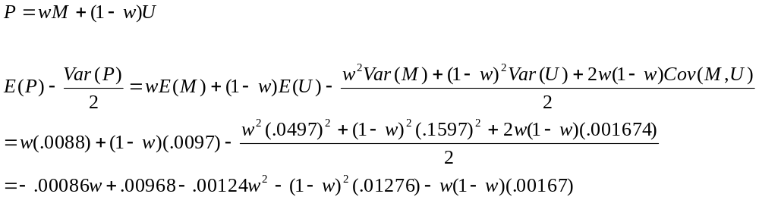
We now take the derivative of this expression with respect to w, set it equal to 0, and solve for w:
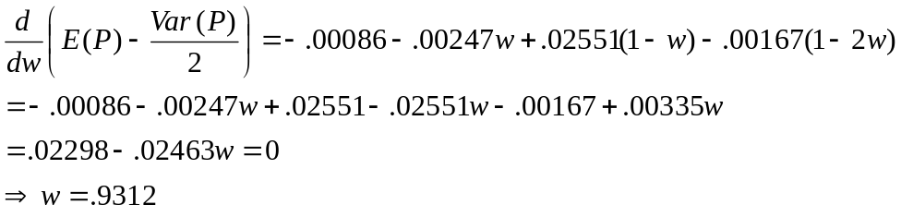
(You may obtain a slightly different value for w because of rounding, or the value .0688 if you set the problem as (1-w)M + wU).

We find that the best portfolio combination for M and U puts 93.28% into M and 6.72% into U.

4. Value at Risk
a) What is the VaR of the $10,000 investment in Company X if we use a confidence level of 99%? In general, what happens to the VaR as the confidence level gets larger?
According to the standard normal model, if Z ~ N(0,1), then P(Z ≤ -2.33) = 0.01. The value at risk is then the position ($10,000) times the mean of the returns for Ford minus 2.33 times the SD of its returns: VaR = 10000 (0.019168 - 2.33 * 0.077009) = $1602.60. The VaR gets steadily larger as the confidence level gets larger. This happens because fewer scenarios are ruled out , allowing for larger possible losses.
b) For a 95% confidence level, find the VaR for a monthly holding period for a $100,000 investment in US Airways using the data in Problem 3 above. What assumptions did you make for this calculation?
The VaR is the position ($100,000) times the mean return minus 1.645 times the SD for US Airways: 100000 (0.0097 - 1.645 * 0.1597) = $25,300, about ¼ of the value of the investment.
Three assumptions are implicit in for this VaR calculation. First, it was assumed that US Airways returns were independent draws from a normal distribution. Second, because we’re setting the mean and SD from historical returns, we have to assume that future returns have these same properties. Three, because we’ve ignored the recent returns themselves, we’re assuming that the future returns are independent of those observed up to the present.
c) A glaring weakness of the VaR measure is its sensitivity to the distributional assumptions. For example, suppose that the actual returns follow a t-distribution instead of a normal distribution. Would the VaR values computed above convey the right degree of risk, or would there be more or less risk? Why?
If the actual returns follow a t-distribution, then two things happen. First, there is a larger probability of an event that is more than 2.326 SDs below the mean. The VaR itself should be larger. (A t-distribution with modestly fat tails puts 50% more probability below the threshold implied by the 99% VaR that assumes normality.) Second, and perhaps more importantly, the amount of the loss may be much, much larger than anticipated by normality. That is, if an adverse event occurs below the VaR limit, it may be much worse than normality anticipates. Outliers that are many SDs below the mean are much more common with the t-distribution than under normality.
5. Decision making
a) If the test raises a red alert, should the company shut down the well to avoid a serious oil spill? What if the test indicates caution?
Use Bayes rule to update the probability that the well produces an oil spill given the outcome of the test. To do this we create the joint probability table
No Spill Spill Total
Red Alert .95(.1)=.095 .05(.7)=.035 .13
Caution .95(.1)=.095 .05(.2)=.010 .105
Green Light .95(.8)=.76 .05(.1)=.005 .765
Total .95 .05

Without the test the expected profit is .05(-30)+.95(10)= $8 billion.
When there is red alert there is a .035/.13 chance of losing $30 billion which outweighs the .095/.13 chance of making $10 billion; the expected profit is negative so the well will be shut down and no money will be made. If the test generates a caution, then such wells have a .095/.105 chance of having no spill and hence have an expected profit of .095/.105(10)-.010/.105(30)= $6.19 billion.
b) Is it worthwhile to engage the test?
The expected profit ignoring a test is 10(0.95)-30(0.05) = $8 billion. Now find the expected profit of the straightforward strategy that uses the test outcome. Completing the calculations, if the test gives the green light, then the expected profit is .76/.765(10)-.005/.765(30)=$9.739 billion. Averaged over the three test outcomes, the expected profit (assuming shutting down if red, drilling otherwise) is .13(0)+.105(6.19)+.765(9.739)=$8.4 billion.
Since the gain is 400 million, it is better to perform the test.

